**A World on Fire or Echoes of the Cold War?**

[**Greg Sanders**](http://csis.org/expert/gregory-sanders)

[**@gregorysanders**](https://twitter.com/gregorysanders)

The horrors of the war in Syria, terrorist attacks, burgeoning refugee crises, the annexation of Crimea, and South China Sea disputes continue to prompt fears about the world’s direction. But, earlier this decade, [Steven Pinker](http://stevenpinker.com/publications/better-angels-our-nature) argued violence was declining with the end of the Cold War and the success of some peacekeeping efforts. Is that good news story obsolete?

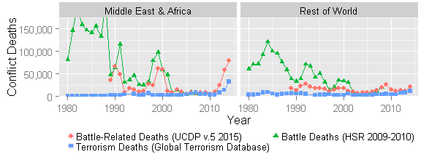

Tracking conflict deaths is difficult, as shown by the gap between [Human Security Report](http://www.hsrgroup.org/) (HSR) and [Uppsala Conflict Data Program](http://www.pcr.uu.se/research/ucdp/datasets/ucdp_battle-related_deaths_dataset/) (UCDP) data. The enormity and complexity of Syria’s ongoing civil war makes it particularly hard to measure. However, certain regional trends are clear. [Terrorism in aggregate has skyrocketed](http://economicsandpeace.org/wp-content/uploads/2015/11/Global-Terrorism-Index-2015.pdf) in countries in conflict, especially in Africa and the Middle East. More than 80 percent of the terrorism losses and 90 percent of the battlefield deaths occurred in eight countries: Iraq, Nigeria, Afghanistan, Syria, Pakistan, Somalia, Ukraine, and Yemen. Despite these conflicts, battlefield deaths on a regional and global level remain well below the tolls of the 1980s, a change the Human Security Report attributes in large part decreasing numbers of interstate conflicts and the end of the Cold War.

We know the 2015 data will include the ceasefire in Ukraine, direct Russian intervention in Syria, and the metastasizing of ISIS terrorism beyond Iraq and Syria. While the global death toll in 2015 will likely remain below half that of three decades ago, significant unknowns remain, Will the absence of proxy conflict help Nigeria move toward peace despite transnational terrorist ties?  Will ISIS terrorism against Russia and NATO civilians prompt cooperation on deescalating Syria's civil war or prompt doubling down on preferred outcomes? In the meantime, this review of history refutes the [Dana Milbank’s criticism that Air Force General Paul Selva is “timid”](https://www.washingtonpost.com/opinions/on-syria-us-military-leaders-offer-only-timidity/2015/12/09/f1dd2b9e-9eb8-11e5-8728-1af6af208198_story.html) for advising against a no fly zone in Syria due to concerns about Russia’s response. Aggregate battlefield death statistics cannot tell us whether a specific tactic is warranted, but they show Syria can easily get worse should proxy conflict escalate between the United States and Russia. 2014’s uptick in violence shows the real failures of current policy, but any replacements cannot dismiss management of great power relations as an afterthought.

. .